Learners’ Survey
Academic Year 2025-2026
IGCSE Girls Campus
IGCSE-I
Dated: September 30, 2025
IG-I Mercury - Girls
Total Reponses: 25
Q#1: Which teachers encourage you the most to ask questions about the topics being studied and are happy to answer them? *You may select as many options as you like.
Name | Responses | Percentage
Ms. Zainab Afridi- English | 17 | 17%
Ms. Ghazal Shariq - Chemistry | 16 | 16%
Ms. Mehak Akhlaq - Physics | 14 | 14%
Dr. Mariam Omer Khan - Biology | 12 | 12%
Ms. Sehrish Abbas - Math | 11 | 11%
Mr. Habib Ur Rehman - Islamiyat | 11 | 11%
Ms. Munazza Waqar - Geography | 11 | 11%
Ms. Rabia Nasir - History | 8 | 8%
Ms. Farrukh Shabahat - Urdu | 2 | 2%
None of the above | 0 | 0%

Q#2: Which teachers report late for the class? * (You may select as many options as you like.)*
Name | Responses | Percentage
Ms. Farrukh Shabahat - Urdu | 7 | 20%
None of the above | 7 | 20%
Ms. Mehak Akhlaq - Physics | 6 | 17%
Ms. Zainab Afridi- English | 4 | 11%
Ms. Rabia Nasir - History | 4 | 11%
Ms. Ghazal Shariq - Chemistry | 3 | 9%
Dr. Mariam Omer Khan - Biology | 2 | 6%
Ms. Munazza Waqar - Geography | 2 | 6%
Ms. Sehrish Abbas - Math | 0 | 0%
Mr. Habib Ur Rehman - Islamiyat | 0 | 0%

Q#3: Which teachers conclude their classes before the allotted time? * (You may select as many options as you like.)
Name | Responses | Percentage
None of the above | 10 | 18%
Mr. Habib Ur Rehman - Islamiyat | 7 | 13%
Ms. Munazza Waqar - Geography | 6 | 11%
Ms. Rabia Nasir - History | 6 | 11%
Ms. Zainab Afridi- English | 5 | 9%
Ms. Farrukh Shabahat - Urdu | 5 | 9%
Ms. Sehrish Abbas - Math | 5 | 9%
Ms. Ghazal Shariq - Chemistry | 5 | 9%
Ms. Mehak Akhlaq - Physics | 5 | 9%
Dr. Mariam Omer Khan - Biology | 1 | 2%

Q#4: Which teachers indulge in irrelevant discussions. * (You may select as many options as you like.)
Name | Responses | Percentage
Ms. Farrukh Shabahat - Urdu | 16 | 47%
Ms. Zainab Afridi- English | 6 | 18%
None of the above | 5 | 15%
Ms. Rabia Nasir - History | 3 | 9%
Dr. Mariam Omer Khan - Biology | 2 | 6%
Ms. Mehak Akhlaq - Physics | 1 | 3%
Ms. Munazza Waqar - Geography | 1 | 3%
Ms. Sehrish Abbas - Math | 0 | 0%
Ms. Ghazal Shariq - Chemistry | 0 | 0%
Mr. Habib Ur Rehman - Islamiyat | 0 | 0%

Q#5: Which teachers use cell phones in their classes? * (You may select as many options as you like.)
Name | Responses | Percentage
None of the above | 21 | 78%
Ms. Farrukh Shabahat - Urdu | 2 | 7%
Dr. Mariam Omer Khan - Biology | 2 | 7%
Ms. Zainab Afridi- English | 1 | 4%
Ms. Rabia Nasir - History | 1 | 4%
Ms. Sehrish Abbas - Math | 0 | 0%
Ms. Ghazal Shariq - Chemistry | 0 | 0%
Ms. Mehak Akhlaq - Physics | 0 | 0%
Mr. Habib Ur Rehman - Islamiyat | 0 | 0%
Ms. Munazza Waqar - Geography | 0 | 0%

Q#6. Which teacher asks you to take paid tuition from him/her in the evening to get an A* or a good grade?
Name | Responses | Percentage
None of the above | 25 | 100%
Ms. Zainab Afridi- English | 0 | 0%
Ms. Farrukh Shabahat - Urdu | 0 | 0%
Ms. Sehrish Abbas - Math | 0 | 0%
Ms. Ghazal Shariq - Chemistry | 0 | 0%
Dr. Mariam Omer Khan - Biology | 0 | 0%
Ms. Mehak Akhlaq - Physics | 0 | 0%
Mr. Habib Ur Rehman - Islamiyat | 0 | 0%
Ms. Munazza Waqar - Geography | 0 | 0%
Ms. Rabia Nasir - History | 0 | 0%

Q#7. Which subject do you find most challenging?
Name | Responses | Percentage
Ms. Mehak Akhlaq - Physics | 16 | 28%
Ms. Munazza Waqar - Geography | 10 | 17%
Ms. Farrukh Shabahat - Urdu | 8 | 14%
Dr. Mariam Omer Khan - Biology | 7 | 12%
Ms. Rabia Nasir - History | 5 | 9%
Ms. Sehrish Abbas - Math | 4 | 7%
Ms. Ghazal Shariq - Chemistry | 4 | 7%
Mr. Habib Ur Rehman - Islamiyat | 3 | 5%
None of the above | 1 | 2%
Ms. Zainab Afridi- English | 0 | 0%

Q#8. How would you rate the teacher’s overall performance?
Name | Ranking
Ms. Zainab Afridi- English | 1
Mr. Habib Ur Rehman - Islamiyat | 2
Ms. Ghazal Shariq - Chemistry | 3
Ms. Mehak Akhlaq - Physics | 4
Ms. Munazza Waqar - Geography | 5
Ms. Sehrish Abbas - Math | 6
Dr. Mariam Omer Khan - Biology | 7
Ms. Rabia Nasir - History | 8
Ms. Farrukh Shabahat - Urdu | 9

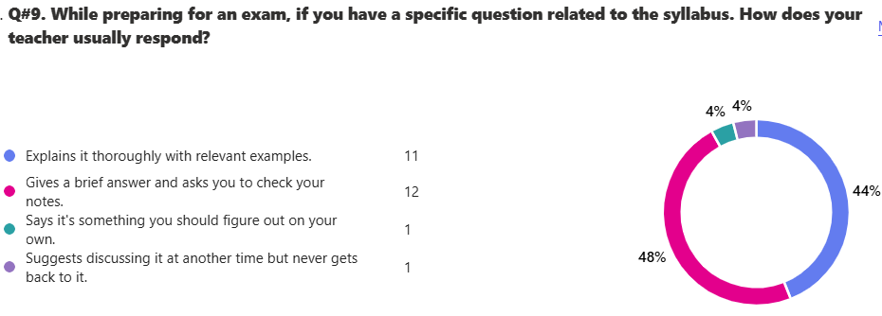

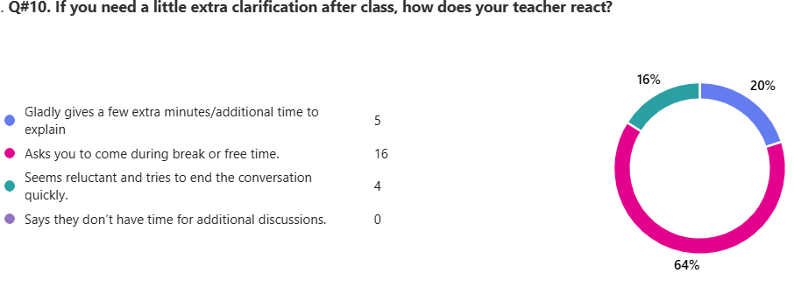

13. Any feedback that you would like to share with Board of Directors.
18 responses

ID | Responses
1 | i would appreciate peer or senior tutoring as teachers aren't often free as they have classes
2 | most teachers are hardworking
3 | i would like that the board of directors focus on the maintenance of the classrooms and hold educational trips to hospitals or any other educational platform
4 | urdu teachers should not be strict
5 | teachers are very kind and helping but some teachers take extra time even after their class has ended. i want Mam Faiza to take our maths as she has been teaching us very good and we want to leanr from her. some teachers get a bit rude sometimes and dont let us out in off time and in break.
6 | some teachers are good while others aren't. I want Ma'am Faiza Farooq to take our Math class in IG 1 Mercury
7 | i would recommend madam Faiza Farooq to be the math teacher of ig 1 mercury
8 | I would like to have a little more clarification for the exams as i am new in this school and shifted from Beaconhouse so i would like the teachers to cooperate more with me if possible. Many tahnks
9 | All the teachers should help the students in their free time and give them extra classes as they wish, teachers should cooperate with the students!:)
10 | some teachers are overly strict without any reason at all and can be a little rude at times
11 | Maam munaza (geography) teacher does the lessons really fast and i dont understand anything about geography. Maam farukh sometimes becomes offensive and threatens me that if i dont stop talking she will hit me. thankyou
12 | I am grateful to get such good teacher in my IGCSE. For each subject, we have to buy handouts and workbooks etc. I believe that this sometimes becomes difficult for the student to manage.
13 | maam furrukh threatens to beat us up
14 | mam Farukh loves to slap and abuse kids as she is always planning to hit us
15 | madam Farukh [ Urdu] threatens to beat us up she targets students saying that she will beats us or slap us madam Zainab is a brilliant teacher she makes sure our syllabus is complete she polite kind and trys to understand our problems so she can clear it up madam Mehak is the same although she gets really mad if our work is incomplete EVERYONE HATES MAAM FARUKH SHE IS MEAN AND HORRIBLE TO US FIR NO REASON SHE THREATENS TO BEAT US UP AND EVEN MY SIBLINGS SAY SHE IS THE WORST TEACHER THEY HAVE EVER MET the bio teacher doesn't care about our problems at all sir habib is vary nice and covers the syllabus on time
16 | maam farrukh the urdu teacher is mean aka says that she would slap us for no reason and targets some specific students . maam munazza of geography also just makes us listen to her and do no word which is bad in my opinion as when i skiped a day of school i didnt understand anything. maam sehrish of maths is mean and if i dont understand anything why dont i listen to anything while she explain while i do but just dont get it.
17 | Kindly ask Ma'am Mehek to not give a lot of homework as we can't give our whole day to studying physics and have to do other subjects revision, homework or assesment revision Kindly make it so that homework is given in minimal amounts a week before assesments.
18 | the teachers are very responsive and explain topics well but some of them do get a bit out of temper for unusual things, and some of them disrespect you, some of them take your lunch breaks or hometime, but my overall experiance with the teachers is good they listen to your queries and give a good responce. but i would want the teachers to take time in explaining hard topics.
IG-I Earth - Girls
Total Reponses: 25
Q#1: Which teachers encourage you the most to ask questions about the topics being studied and are happy to answer them? *You may select as many options as you like.
Name | Responses | Percentage
Ms. Faiza Farooq - Math | 19 | 22%
Ms. Mahwish Dar - English | 13 | 15%
Ms. Nida Asim - Physics | 10 | 12%
Ms. Fauzia Shaheen - Chemistry | 9 | 11%
Ms. Shazia Anjum - Computer Science | 9 | 11%
Ms. Rabia Nasir - Geography | 9 | 11%
Ms. Natasha Omer - Islamiyat | 8 | 9%
Ms. Samira Afzal - History | 7 | 8%
Ms. Farrukh Shabahat - Urdu | 1 | 1%
None of the above | 0 | 0%

Q#2: Which teachers report late for the class? * (You may select as many options as you like.)*
Name | Responses | Percentage
None of the above | 13 | 45%
Ms. Samira Afzal - History | 5 | 17%
Ms. Farrukh Shabahat - Urdu | 3 | 10%
Ms. Fauzia Shaheen - Chemistry | 2 | 7%
Ms. Shazia Anjum - Computer Science | 2 | 7%
Ms. Nida Asim - Physics | 2 | 7%
Ms. Rabia Nasir - Geography | 2 | 7%
Ms. Mahwish Dar - English | 0 | 0%
Ms. Faiza Farooq - Math | 0 | 0%
Ms. Natasha Omer - Islamiyat | 0 | 0%

Q#3: Which teachers conclude their classes before the allotted time?* (You may select as many options as you like.)
Name | Responses | Percentage
None of the above | 20 | 59%
Ms. Nida Asim - Physics | 3 | 9%
Ms. Mahwish Dar - English | 2 | 6%
Ms. Fauzia Shaheen - Chemistry | 2 | 6%
Ms. Shazia Anjum - Computer Science | 2 | 6%
Ms. Natasha Omer - Islamiyat | 2 | 6%
Ms. Farrukh Shabahat - Urdu | 1 | 3%
Ms. Faiza Farooq - Math | 1 | 3%
Ms. Rabia Nasir - Geography | 1 | 3%
Ms. Samira Afzal - History | 0 | 0%

Q#4: Which teachers indulge in irrelevant discussions. * (You may select as many options as you like.)
Name | Responses | Percentage
Ms. Farrukh Shabahat - Urdu | 9 | 32%
None of the above | 9 | 32%
Ms. Nida Asim - Physics | 6 | 21%
Ms. Natasha Omer - Islamiyat | 2 | 7%
Ms. Samira Afzal - History | 2 | 7%
Ms. Mahwish Dar - English | 0 | 0%
Ms. Faiza Farooq - Math | 0 | 0%
Ms. Fauzia Shaheen - Chemistry | 0 | 0%
Ms. Shazia Anjum - Computer Science | 0 | 0%
Ms. Rabia Nasir - Geography | 0 | 0%

Q#5: Which teachers use cell phones in their classes? * (You may select as many options as you like.)
Name | Responses | Percentage
None of the above | 24 | 89%
Ms. Samira Afzal - History | 2 | 7%
Ms. Nida Asim - Physics | 1 | 4%
Ms. Mahwish Dar - English | 0 | 0%
Ms. Farrukh Shabahat - Urdu | 0 | 0%
Ms. Faiza Farooq - Math | 0 | 0%
Ms. Fauzia Shaheen - Chemistry | 0 | 0%
Ms. Shazia Anjum - Computer Science | 0 | 0%
Ms. Natasha Omer - Islamiyat | 0 | 0%
Ms. Rabia Nasir - Geography | 0 | 0%

Q#6. Which teacher asks you to take paid tuition from him/her in the evening to get an A* or a good grade?
Name | Responses | Percentage
None of the above | 24 | 92%
Ms. Nida Asim - Physics | 1 | 4%
Ms. Samira Afzal - History | 1 | 4%
Ms. Mahwish Dar - English | 0 | 0%
Ms. Farrukh Shabahat - Urdu | 0 | 0%
Ms. Faiza Farooq - Math | 0 | 0%
Ms. Fauzia Shaheen - Chemistry | 0 | 0%
Ms. Shazia Anjum - Computer Science | 0 | 0%
Ms. Natasha Omer - Islamiyat | 0 | 0%
Ms. Rabia Nasir - Geography | 0 | 0%

Q#7. Which subject do you find most challenging?
Name | Responses | Percentage
Ms. Nida Asim - Physics | 12 | 34%
Ms. Fauzia Shaheen - Chemistry | 7 | 20%
Ms. Farrukh Shabahat - Urdu | 6 | 17%
Ms. Rabia Nasir - Geography | 4 | 11%
Ms. Natasha Omer - Islamiyat | 3 | 9%
Ms. Faiza Farooq - Math | 1 | 3%
Ms. Samira Afzal - History | 1 | 3%
None of the above | 1 | 3%
Ms. Mahwish Dar - English | 0 | 0%
Ms. Shazia Anjum - Computer Science | 0 | 0%

Name | Ranking
Ms. Faiza Farooq - Math | 1
Ms. Shazia Anjum - Computer Science | 2
Ms. Natasha Omer - Islamiyat | 3
Ms. Mahwish Dar - English | 4
Ms. Fauzia Shaheen - Chemistry | 5
Ms. Rabia Nasir - Geography | 6
Ms. Samira Afzal - History | 7
Ms. Nida Asim - Physics | 8
Ms. Farrukh Shabahat - Urdu | 9
Q#8. How would you rate the teacher’s overall performance?

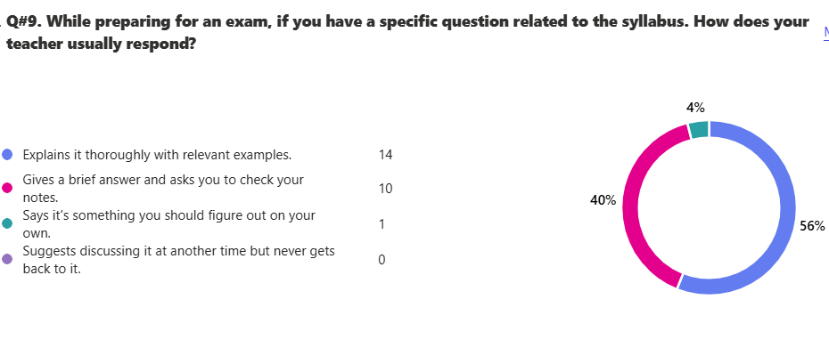
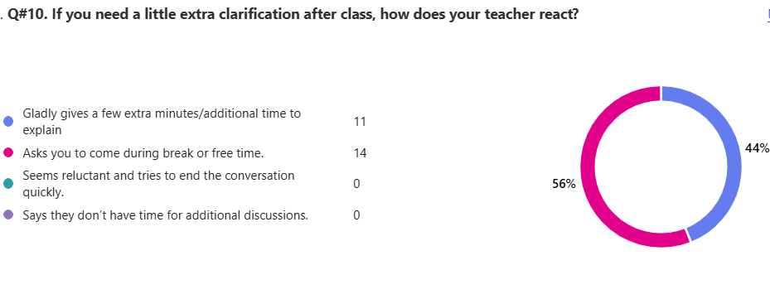

13. Any feedback that you would like to share with Board of Directors.
20 responses

ID | Responses
1 | The teachers are overall average in ig1 but some are extremely helpful and loving ... they do help .. however i am afraid to ask questions from some teachers ( i would not like to name) .... i would suggest that teachers should have a nice bond between the students and should be happy to answer them ... some teachers need to be mindful with the language they are using.
2 | excellent baji.love her.
3 | nice staff
4 | excellant staff , hardworking teachers , but the school buildng should be improved, shool chairs should be improved need to be more spacious and comftable . more school events , improved canteen . i love the floor baji she is great
5 | Excellent and precisely chosen teachers very well thought out and due to their teaching style students learn well and achieve higher scores. The extra teacher hired specifically for maths also helps struggling girls solve with ease. Staff are also my polite and nice. One thing that maam natasha our islamiat teacher doesnt make us write according to scheme so i was a bit worried about that else amazing work directors!
6 | I would like it if chemistry teacher would go through previous topics again before exams.
7 | more activities
8 | Mam nida asim does not expain the lecture very well
9 | The teachers are very nice, and not only nice but also really good at teaching but the Urdu teacher doesn't explain the questions very well and whenever we ask a question, she says figure out on your own, even though the person actually needs help. Other than that, I love the teachers and the extra fun they let us have beside from studies, and I would love to see the school bringing in extra curricular, like sports day or better playing grounds from sports. Overall, the school is amazing and the teachers are nice, and amazing at teaching.
10 | i love all of my teachers they explain concepts very well and are always ready to help except ma'am farukh she teaches well its just that i think she doesn't like us
11 | I would like to say that the teachers are perfect and would not say no to any questions except mam Farrukh she would not use to answer some of the questions. she would take it as an irrelavant question. overall i would like to say that everthing is perfectly arranged and well focused
12 | ALL teachers are very nice
13 | All the teachers are really good and I understand very well from them but have some difficulties in Urdu
14 | the teachers are very nice, whenever a question is not clear. They explain it briefly or ask to come in break or any free class. I love the way that this school lets you have fun and extra curricular activities side by side with academics. I honestly had a good experience in this school but one thing is that I don't like is that the urdu teacher doesn't really pays attention to our questions. No doubt that she explains really good but the point is that whenever she gives us a class task, she tells us NOT to ask questions from our classmates and tells us to ask from her. But whenever we ask something related to the task, she says that it's irrelevant while the question is very important.
15 | sometimes irrelvent disscusion is useful .mam urdu scold us when we are late for atleast 2 minutes
16 | All teachers are really good but i am weak in physics and geography so I would suggest that teachers are avaliable at break
17 | too many test over all
18 | The urdu teacher Ms Farukh Shabahat does not let us ask her questions during class. Miss Nida Asim for physics does not explain the topics well and gives us the whole workbook for hw and she is going too fast.
19 | We have to prepare for test everday. THANKYOU!!!
20 | some teachers (not taking names *Urdu*) seem extremely reluctant to answer any queries, and asks the student to understand it on their own, yells at someone and makes fun of them if they mispronounce a word wrong while reading, while talking about manners herself. Another thing is I know I talk a lot, but the teachers don't notice the others talking, and only yell at ME and only change MY seat... that's NOT fair.

IG-I Mars - Girls
Total Reponses: 18
Q#1: Which teachers encourage you the most to ask questions about the topics being studied and are happy to answer them? *You may select as many options as you like.
Name | Responses | Percentage
Ms. Zainab Afridi- English | 13 | 17%
Ms. Sehrish Abbasi - Math | 11 | 14%
Ms. Mehak Akhlaq - Physics | 11 | 14%
Ms. Sadaf Abudullah - Biology | 9 | 12%
Ms. Farah Imran - Geography | 8 | 10%
Ms. Natasha Omer - Islamiyat | 7 | 9%
Ms. Rabia Nasir - History | 7 | 9%
Ms. Fauzia Tabassum - Urdu | 6 | 8%
Ms. Saman Ali- Chemistry | 5 | 6%
None of the above | 0 | 0%

Q#2: Which teachers report late for the class? * (You may select as many options as you like.)*
Name | Responses | Percentage
None of the above | 13 | 57%
Ms. Sadaf Abudullah - Biology | 4 | 17%
Ms. Mehak Akhlaq - Physics | 2 | 9%
Ms. Farah Imran - Geography | 2 | 9%
Ms. Fauzia Tabassum - Urdu | 1 | 4%
Ms. Rabia Nasir - History | 1 | 4%
Ms. Zainab Afridi- English | 0 | 0%
Ms. Sehrish Abbasi - Math | 0 | 0%
Ms. Saman Ali- Chemistry | 0 | 0%
Ms. Natasha Omer - Islamiyat | 0 | 0%

Q#3: Which teachers conclude their classes before the allotted time? * (You may select as many options as you like.)
Name | Responses | Percentage
None of the above | 11 | 41%
Ms. Zainab Afridi- English | 4 | 15%
Ms. Saman Ali- Chemistry | 3 | 11%
Ms. Fauzia Tabassum - Urdu | 2 | 7%
Ms. Sehrish Abbasi - Math | 2 | 7%
Ms. Natasha Omer - Islamiyat | 2 | 7%
Ms. Sadaf Abudullah - Biology | 1 | 4%
Ms. Farah Imran - Geography | 1 | 4%
Ms. Rabia Nasir - History | 1 | 4%
Ms. Mehak Akhlaq - Physics | 0 | 0%

Q#4: Which teachers indulge in irrelevant discussions. * (You may select as many options as you like.)
Name | Responses | Percentage
None of the above | 9 | 39%
Ms. Zainab Afridi- English | 8 | 35%
Ms. Natasha Omer - Islamiyat | 3 | 13%
Ms. Fauzia Tabassum - Urdu | 2 | 9%
Ms. Mehak Akhlaq - Physics | 1 | 4%
Ms. Sehrish Abbasi - Math | 0 | 0%
Ms. Saman Ali- Chemistry | 0 | 0%
Ms. Sadaf Abudullah - Biology | 0 | 0%
Ms. Farah Imran - Geography | 0 | 0%
Ms. Rabia Nasir - History | 0 | 0%

Q#5: Which teachers use cell phones in their classes? * (You may select as many options as you like.)
Name | Responses | Percentage
None of the above | 17 | 94%
Ms. Fauzia Tabassum - Urdu | 1 | 6%
Ms. Zainab Afridi- English | 0 | 0%
Ms. Sehrish Abbasi - Math | 0 | 0%
Ms. Saman Ali- Chemistry | 0 | 0%
Ms. Sadaf Abudullah - Biology | 0 | 0%
Ms. Mehak Akhlaq - Physics | 0 | 0%
Ms. Natasha Omer - Islamiyat | 0 | 0%
Ms. Farah Imran - Geography | 0 | 0%
Ms. Rabia Nasir - History | 0 | 0%

Q#6. Which teacher asks you to take paid tuition from him/her in the evening to get an A* or a good grade?
Name | Responses | Percentage
None of the above | 18 | 95%
Ms. Fauzia Tabassum - Urdu | 1 | 5%
Ms. Zainab Afridi- English | 0 | 0%
Ms. Sehrish Abbasi - Math | 0 | 0%
Ms. Saman Ali- Chemistry | 0 | 0%
Ms. Sadaf Abudullah - Biology | 0 | 0%
Ms. Mehak Akhlaq - Physics | 0 | 0%
Ms. Natasha Omer - Islamiyat | 0 | 0%
Ms. Farah Imran - Geography | 0 | 0%
Ms. Rabia Nasir - History | 0 | 0%

Q#7. Which subject do you find most challenging?
Name | Responses | Percentage
Ms. Mehak Akhlaq - Physics | 8 | 31%
Ms. Sehrish Abbasi - Math | 3 | 12%
Ms. Saman Ali- Chemistry | 3 | 12%
Ms. Farah Imran - Geography | 3 | 12%
Ms. Zainab Afridi- English | 2 | 8%
Ms. Fauzia Tabassum - Urdu | 2 | 8%
Ms. Sadaf Abudullah - Biology | 2 | 8%
Ms. Rabia Nasir - History | 2 | 8%
None of the above | 1 | 4%
Ms. Natasha Omer - Islamiyat | 0 | 0%

Q#8. How would you rate the teacher’s overall performance?
Name | Ranking
Ms. Mehak Akhlaq - Physics | 1
Ms. Fauzia Tabassum - Urdu | 2
Ms. Zainab Afridi- English | 3
Ms. Natasha Omer - Islamiyat | 4
Ms. Saman Ali- Chemistry | 5
Ms. Farah Imran - Geography | 6
Ms. Sadaf Abudullah - Biology | 7
Ms. Rabia Nasir - History | 8
Ms. Sehrish Abbasi - Math | 9

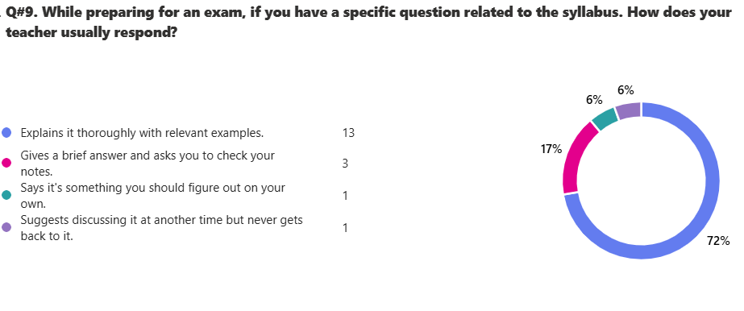
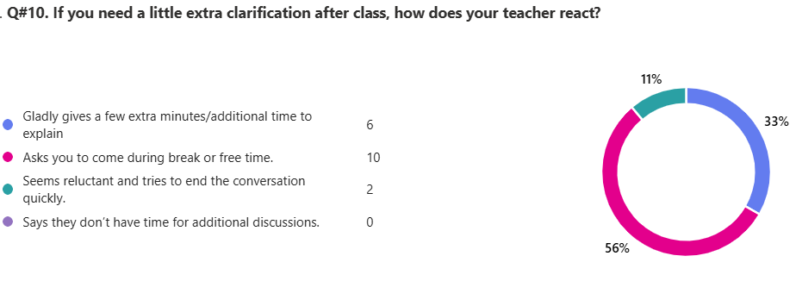

13. Any feedback that you would like to share with Board of Directors.
10 responses

ID | Responses
1 | i like all teachers.
2 | I would suggest reducing the photocopy prices because all subjects require notes from there because they aren't able to print it at home, or, teachers could distribute the notes themselves and take payment from the students
3 | I can't understand chemistry and history really well because the chemistry teacher just explains a concept once and then gives rest of the work as homework , the history teacher doesn't explain that clearly and makes a flow chart of the answers other students have given so I just stay there dumbfounded not knowing anything , besides she tends to skip some of the topics as she said that the students have done it in grade 7 and they have great prior knowledge but I'm a new admission and find it hard to compete with the rest of the class in history
4 | so far, I am pleased to inform that my studies are going well though I have faced a few speedbumps i am on track and hope to deliver good grades
5 | overall the teachers are very experienced and explains each concept to us thoroughly.
6 | overall teaching is good, and all are very experienced.
7 | The teachers overall are amazing, but they tend to give either too much work or too little time to complete home tasks. I get that they want to help us and make our timings right but personally I got a lot of homework this weekend. I got very stressed out and in fear of completing my work in 'three' days (I had other events as well e.g. a wedding) i spent all my nights studying and prioritized my work over sleep and didn't close my eye even for a second in fear of completing all the work.
8 | All the teachers are amazing, hardworking and dedicated to their profession.
9 | There should be a proper class where each student could come up with questions not only specific for the subjects but the general o level system as well since lots of IG-1 i know are not aware. The teachers if you ask them to explain they say they would but they don't, they teach in such a speed that you cant comprehend and if they do explain then they try to end the conversation quickly .Teachers should also introduce kids to time mangement techniques and efficent study methods for the subjects as the amount of work is alot and hard to manage.
10 | All of the Teachers are very Hardworking , They put alot of efforts and always motivate us for doing more better , they always give a lot of time for class discusion and try their best to encourage students , they tell students to come in break if they dont understand anything and ARE ALWAYS there even if you ask from them on phone every time they clear out our misconceptions , Any of the teacher does not come late neither leave the class early , Physics , geography , chemistry , islamiat they all are amazing ! i love the way they clear our misconceptions , encourage us , discuss past papers in class and even teach and understand us on phone !

IG-I Jupiter - Girls
Total Reponses: 16
Q#1: Which teachers encourage you the most to ask questions about the topics being studied and are happy to answer them? *You may select as many options as you like.
Name | Responses | Percentage
Ms. Faiza Farooq - Math | 14 | 24%
Ms. Khawaja Zahid - History | 9 | 16%
Mr. Muhammad Bilal - Urdu | 8 | 14%
Ms. Mehak Akhlaq - Physics | 7 | 12%
Ms. Munazza Waqar - Geography | 6 | 10%
Ms. Mahwish Dar - English | 5 | 9%
Ms. Saman Ali- Chemistry | 5 | 9%
Ms. Anila Rafaqat - Biology | 3 | 5%
Ms. Rubina Akhtar - Islamiyat | 1 | 2%
None of the above | 0 | 0%

Q#2: Which teachers report late for the class? * (You may select as many options as you like.)*
Name | Responses | Percentage
None of the above | 10 | 56%
Ms. Anila Rafaqat - Biology | 3 | 17%
Mr. Muhammad Bilal - Urdu | 1 | 6%
Ms. Faiza Farooq - Math | 1 | 6%
Ms. Saman Ali- Chemistry | 1 | 6%
Ms. Rubina Akhtar - Islamiyat | 1 | 6%
Ms. Munazza Waqar - Geography | 1 | 6%
Ms. Mahwish Dar - English | 0 | 0%
Ms. Mehak Akhlaq - Physics | 0 | 0%
Ms. Khawaja Zahid - History | 0 | 0%

Q#3: Which teachers conclude their classes before the allotted time? * (You may select as many options as you like.)
Name | Responses | Percentage
None of the above | 13 | 76%
Mr. Muhammad Bilal - Urdu | 2 | 12%
Ms. Rubina Akhtar - Islamiyat | 1 | 6%
Ms. Munazza Waqar - Geography | 1 | 6%
Ms. Mahwish Dar - English | 0 | 0%
Ms. Faiza Farooq - Math | 0 | 0%
Ms. Saman Ali- Chemistry | 0 | 0%
Ms. Anila Rafaqat - Biology | 0 | 0%
Ms. Mehak Akhlaq - Physics | 0 | 0%
Ms. Khawaja Zahid - History | 0 | 0%

Q#4: Which teachers indulge in irrelevant discussions. * (You may select as many options as you like.)
Name | Responses | Percentage
None of the above | 13 | 82%
Ms. Mahwish Dar - English | 1 | 6%
Ms. Munazza Waqar - Geography | 1 | 6%
Ms. Khawaja Zahid - History | 1 | 6%
Mr. Muhammad Bilal - Urdu | 0 | 0%
Ms. Faiza Farooq - Math | 0 | 0%
Ms. Saman Ali- Chemistry | 0 | 0%
Ms. Anila Rafaqat - Biology | 0 | 0%
Ms. Mehak Akhlaq - Physics | 0 | 0%
Ms. Rubina Akhtar - Islamiyat | 0 | 0%

Q#5: Which teachers use cell phones in their classes? * (You may select as many options as you like.)
Name | Responses | Percentage
None of the above | 15 | 94%
Ms. Rubina Akhtar - Islamiyat | 1 | 6%
Ms. Mahwish Dar - English | 0 | 0%
Mr. Muhammad Bilal - Urdu | 0 | 0%
Ms. Faiza Farooq - Math | 0 | 0%
Ms. Saman Ali- Chemistry | 0 | 0%
Ms. Anila Rafaqat - Biology | 0 | 0%
Ms. Mehak Akhlaq - Physics | 0 | 0%
Ms. Munazza Waqar - Geography | 0 | 0%
Ms. Khawaja Zahid - History | 0 | 0%

Q#6. Which teacher asks you to take paid tuition from him/her in the evening to get an A* or a good grade?
Name | Responses | Percentage
None of the above | 16 | 94%
Ms. Saman Ali- Chemistry | 1 | 6%
Ms. Mahwish Dar - English | 0 | 0%
Mr. Muhammad Bilal - Urdu | 0 | 0%
Ms. Faiza Farooq - Math | 0 | 0%
Ms. Anila Rafaqat - Biology | 0 | 0%
Ms. Mehak Akhlaq - Physics | 0 | 0%
Ms. Rubina Akhtar - Islamiyat | 0 | 0%
Ms. Munazza Waqar - Geography | 0 | 0%
Ms. Khawaja Zahid - History | 0 | 0%

Q#7. Which subject do you find most challenging?
Name | Responses | Percentage
Ms. Mehak Akhlaq - Physics | 8 | 30%
Ms. Munazza Waqar - Geography | 5 | 19%
Ms. Saman Ali- Chemistry | 4 | 15%
Ms. Anila Rafaqat - Biology | 4 | 15%
Mr. Muhammad Bilal - Urdu | 2 | 7%
Ms. Rubina Akhtar - Islamiyat | 2 | 7%
Ms. Faiza Farooq - Math | 1 | 4%
None of the above | 1 | 4%
Ms. Mahwish Dar - English | 0 | 0%
Ms. Khawaja Zahid - History | 0 | 0%

Q#8. How would you rate the teacher’s overall performance?
Name | Responses
Ms. Faiza Farooq - Math | 1
Ms. Khawaja Zahid - History | 2
Ms. Mehak Akhlaq - Physics | 3
Ms. Saman Ali- Chemistry | 4
Mr. Muhammad Bilal - Urdu | 5
Ms. Mahwish Dar - English | 6
Ms. Munazza Waqar - Geography | 7
Ms. Anila Rafaqat - Biology | 8
Ms. Rubina Akhtar - Islamiyat | 9

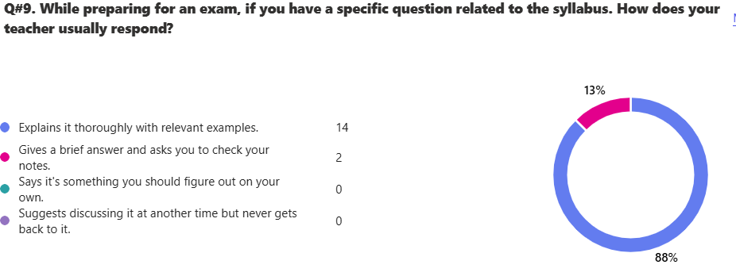

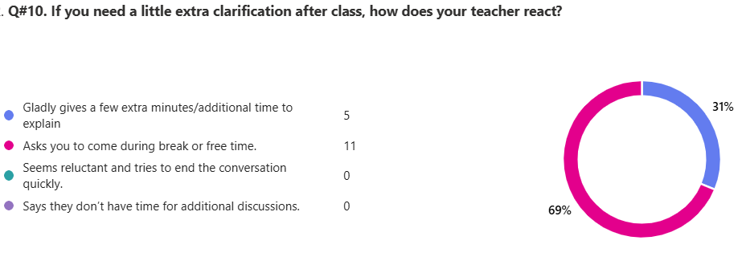

13. Any feedback that you would like to share with Board of Directors.
12 responses

ID | Responses
1 | maam mehak isnt a very good teacher
2 | no
3 | maam faiza and maam mehak teach very well and help explain the questions throughly and properly
4 | overall teachers are very nice but mama rubina doesn't seem quiet pleased to answer questions and isnt very enthusiastic abot teaching over class
5 | All the teachers are very nice but islamiat teacher doesnt teach much.
6 | Maam Faiza is an amazing teacher and that i hope that even next year she continues to teach us maths. Maam Rubinas class is quiet boring and dull.
7 | on pop quiz some of the teachers may close you break or waste the whole class while getting angry at you, could you please tell them to be a little kinder towards the students?
8 | they should change our islamiyat teacher as she doesnt give us copywork in the school and then gives it all for home which pressurazies us and makes us lazy as well.
9 | Ma,am Mehak is my favourite teacher as she explains very nicely and listens to your questions she always gets happy if we ask any questions but she sometimes gets very strict if u dont do your work on time or if ur not paying attention .and maam faiza and maam saman and sir zahid are the same he makes the class fun.the school is nice but there are not even a single games in a week and we only get to play at break.
10 | nothing
11 | all the teachers r wonderful
12 | all teachers are excellent and good at teaching and making us understand the topics .

IG-I Venus Computer Science - Girls
Total Reponses: 19
Q#1: Which teachers encourage you the most to ask questions about the topics being studied and are happy to answer them? *You may select as many options as you like.
Name | Responses | Percentage
Ms. Nazish Anjum - Chemistry | 17 | 31%
Ms. Nida Asim - Physics | 9 | 16%
Mr. Habib Ur Rehman - Islamiyat | 6 | 11%
Ms. Munazza Waqar - Geography | 5 | 9%
Ms. Samira Afzal - History | 5 | 9%
Ms. Ayesha Shoaib - English | 4 | 7%
Dr. Mariam Omer Khan - Biology | 4 | 7%
Ms. Fauzia Tabassum - Urdu | 3 | 5%
Ms. Naureen Malik - Math | 2 | 4%
None of the above | 0 | 0%

Q#2: Which teachers report late for the class? * (You may select as many options as you like.)*
Name | Responses | Percentage
None of the above | 9 | 33%
Ms. Naureen Malik - Math | 5 | 19%
Ms. Samira Afzal - History | 5 | 19%
Ms. Nida Asim - Physics | 4 | 15%
Ms. Munazza Waqar - Geography | 2 | 7%
Ms. Ayesha Shoaib - English | 1 | 4%
Dr. Mariam Omer Khan - Biology | 1 | 4%
Ms. Fauzia Tabassum - Urdu | 0 | 0%
Ms. Nazish Anjum - Chemistry | 0 | 0%
Mr. Habib Ur Rehman - Islamiyat | 0 | 0%

Q#3: Which teachers conclude their classes before the allotted time? * (You may select as many options as you like.)
Name | Responses | Percentage
None of the above | 13 | 50%
Dr. Mariam Omer Khan - Biology | 3 | 12%
Ms. Samira Afzal - History | 3 | 12%
Ms. Fauzia Tabassum - Urdu | 2 | 8%
Ms. Naureen Malik - Math | 2 | 8%
Ms. Nazish Anjum - Chemistry | 1 | 4%
Ms. Nida Asim - Physics | 1 | 4%
Ms. Munazza Waqar - Geography | 1 | 4%
Ms. Ayesha Shoaib - English | 0 | 0%
Mr. Habib Ur Rehman - Islamiyat | 0 | 0%

Q#4: Which teachers indulge in irrelevant discussions. * (You may select as many options as you like.)
Name | Responses | Percentage
None of the above | 10 | 48%
Ms. Fauzia Tabassum - Urdu | 7 | 33%
Ms. Nida Asim - Physics | 2 | 10%
Ms. Ayesha Shoaib - English | 1 | 5%
Dr. Mariam Omer Khan - Biology | 1 | 5%
Ms. Naureen Malik - Math | 0 | 0%
Ms. Nazish Anjum - Chemistry | 0 | 0%
Mr. Habib Ur Rehman - Islamiyat | 0 | 0%
Ms. Munazza Waqar - Geography | 0 | 0%
Ms. Samira Afzal - History | 0 | 0%

Q#5: Which teachers use cell phones in their classes? * (You may select as many options as you like.)
Name | Responses | Percentage
None of the above | 16 | 59%
Ms. Fauzia Tabassum - Urdu | 3 | 11%
Ms. Ayesha Shoaib - English | 2 | 7%
Dr. Mariam Omer Khan - Biology | 2 | 7%
Ms. Samira Afzal - History | 2 | 7%
Ms. Naureen Malik - Math | 1 | 4%
Ms. Nida Asim - Physics | 1 | 4%
Ms. Nazish Anjum - Chemistry | 0 | 0%
Mr. Habib Ur Rehman - Islamiyat | 0 | 0%
Ms. Munazza Waqar - Geography | 0 | 0%

Q#6. Which teacher asks you to take paid tuition from him/her in the evening to get an A* or a good grade?
Name | Responses | Percentage
None of the above | 17 | 89%
Ms. Fauzia Tabassum - Urdu | 1 | 5%
Ms. Samira Afzal - History | 1 | 5%
Ms. Ayesha Shoaib - English | 0 | 0%
Ms. Naureen Malik - Math | 0 | 0%
Ms. Nazish Anjum - Chemistry | 0 | 0%
Dr. Mariam Omer Khan - Biology | 0 | 0%
Ms. Nida Asim - Physics | 0 | 0%
Mr. Habib Ur Rehman - Islamiyat | 0 | 0%
Ms. Munazza Waqar - Geography | 0 | 0%

Q#7. Which subject do you find most challenging?
Name | Responses | Percentage
Ms. Nida Asim - Physics | 10 | 26%
Ms. Naureen Malik - Math | 6 | 16%
Ms. Munazza Waqar - Geography | 6 | 16me%
Dr. Mariam Omer Khan - Biology | 4 | 11%
Mr. Habib Ur Rehman - Islamiyat | 4 | 11%
Ms. Ayesha Shoaib - English | 2 | 5%
Ms. Nazish Anjum - Chemistry | 2 | 5%
Ms. Samira Afzal - History | 2 | 5%
Ms. Fauzia Tabassum - Urdu | 1 | 3%
None of the above | 1 | 3%

Q#8. How would you rate the teacher’s overall performance?
Name | Responses
Ms. Nazish Anjum - Chemistry | 1
Ms. Nida Asim - Physics | 2
Ms. Fauzia Tabassum - Urdu | 3
Mr. Habib Ur Rehman - Islamiyat | 4
Dr. Mariam Omer Khan - Biology | 5
Ms. Samira Afzal - History | 6
Ms. Ayesha Shoaib - English | 7
Ms. Munazza Waqar - Geography | 8
Ms. Naureen Malik - Math | 9

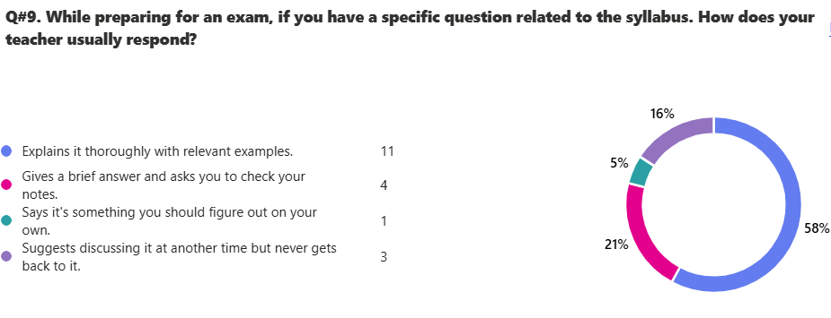

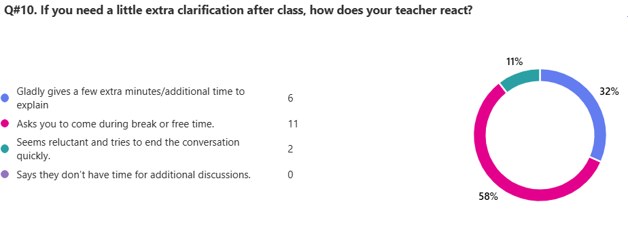
13. Any feedback that you would like to share with Board of Directors.
15 responses

ID | Responses
1 | The teachers are good but some of them are those who i cant understand. The way of maths teachers explanation is not as good.
2 | i would like to share that the washroom's should be hygienic and be clean and the teacher should allow girls to go to the washrrom as it our right, and it can be an emergency.
3 | I feel like the canteen's prices are a bit overpriced and think that it should be lowered to a cheaper price.
4 | I think we have a lot of sylllabus especially for geography and Islamiat
5 | almost all teachers except maybe one are very good at teaching and explaining, as well as answering any inquiries of students. they all are exceptional and ranking them isn't very accurate. however, in english there is a lack of control in the class and we do not advance to other topics or get a thorough explanation as well as we should.
6 | i think all the teachers explain the topics well but there is room for improvement for some like English.
7 | no
8 | overall its good
9 | I would like the math's teacher to explain in a better way as her explanation doesn't seem to get my fellow class members, plus I would like the physics teacher to explain things more clearly with more examples.
10 | The teachers give a lot of homework during assesment period which increases work load
11 | Some of the teachers should be more cooperative with the students.But other then that mostly all teachers are great
12 | i can not understand the math teacher at all moreover she explains one question and more than 10 pages are for homework everyday the english teacher scolds us when it is the ig3 packup time that the speakers are annoying moreover you guys are being annoying meanwhile noone is doing anything wrong once the geo teacher makes us do no work in the copy and explains few chunks only that can not be understood by me the urdu teacher talks slang language with us and she is rude once she telling someone in our class to read and had her finger on the word that specific student said mam can you remove your finger the teacher scolded her and called maam halima to take her to the office the history teacher is about throw marker pens dusters and bottles and once she threw a duster and a maker on some student the physics teacher is very bias with the good kids who score good in tests the chemistry teacher takes everyone on a same page moreover she is a very nice and a humble teacher
13 | teachers need to be more cooperative and over all they are nice and kind but also try to give less h.w because in we need to revise the daily concepts practice and we also need time for ourselves as well. thank you !
14 | i would like to share that the bio teacher miss mariam has a very harsh and rude behaviour with me and the maths teacher comes every time and sits and tells student to come and solve and when we dont know the answer she insult them plus the history and the urdu teacher alays forget that they have class like everytime plus the school should have a better common room cause in the break we dont have any place to sit outside plus our ac doesnt work and the chairs are even broken and our CR TALIA DANEEN CHAUDARY she has alot of attitude and even misbehaves with teacher and tells everyone if you misbehave with me ill remove you from the groups as i am the incharge of all groups i would like that the teachers should be a bit polite towards the students and as i have recently shifted to bio from c.c i have told dr marriam to help me wih bio but she says its not her fault that i have just shifted and if i fail thats up on me and she doent even allow us to use washroom i would like that bussines student should have a seprate section to and we want our cr to be change thank you
15 | I really like all of my teachers also maam nazish anjum the chemistry teacher is the best and helps a lot during discussions although the math teacher is very nice and all but she does not explain the concept clearly and when we ask her that we have a confusion in any math problem she does not explain it and only solves it in front of you which does not clear the concept rather creates a confusion she should explain the question a bit more furthermore when we ask her to explain a question she writes it with her red pen which makes it look a bit awkward and even if we insist she does not use a pencil. although all of my teachers are amazing and I like them all.
IG-I Venus Business Studies - Girls
Total Reponses: 12
Q#1: Which teachers encourage you the most to ask questions about the topics being studied and are happy to answer them? *You may select as many options as you like.
Name | Responses | Percentage
Ms. Inshal Noor - Business Studies | 5 | 17%
Ms. Fauzia Tabassum - Urdu | 4 | 13%
Ms. Naureen Malik - Math | 3 | 10%
Ms. Saqib Tariq - Economics | 3 | 10%
Mr. Habib Ur Rehman - Islamiyat | 3 | 10%
Ms. Samira Afzal - History | 3 | 10%
None of the above | 3 | 10%
Ms. Ayesha Shoaib - English | 2 | 7%
Ms. M. Taha Zaidi - Accounting | 2 | 7%
Ms. Munazza Waqar - Geography | 2 | 7%

Q#2: Which teachers report late for the class? * (You may select as many options as you like.)*
Name | Responses | Percentage
None of the above | 10 | 71%
Ms. Samira Afzal - History | 2 | 14%
Ms. Fauzia Tabassum - Urdu | 1 | 7%
Ms. Inshal Noor - Business Studies | 1 | 7%
Ms. Ayesha Shoaib - English | 0 | 0%
Ms. Naureen Malik - Math | 0 | 0%
Ms. Saqib Tariq - Economics | 0 | 0%
Ms. M. Taha Zaidi - Accounting | 0 | 0%
Mr. Habib Ur Rehman - Islamiyat | 0 | 0%
Ms. Munazza Waqar - Geography | 0 | 0%

Q#3: Which teachers conclude their classes before the allotted time? * (You may select as many options as you like.)
Name | Responses | Percentage
None of the above | 8 | 53%
Ms. Saqib Tariq - Economics | 2 | 13%
Mr. Habib Ur Rehman - Islamiyat | 2 | 13%
Ms. Ayesha Shoaib - English | 1 | 7%
Ms. Inshal Noor - Business Studies | 1 | 7%
Ms. M. Taha Zaidi - Accounting | 1 | 7%
Ms. Fauzia Tabassum - Urdu | 0 | 0%
Ms. Naureen Malik - Math | 0 | 0%
Ms. Munazza Waqar - Geography | 0 | 0%
Ms. Samira Afzal - History | 0 | 0%

Q#4: Which teachers indulge in irrelevant discussions. * (You may select as many options as you like.)
Name | Responses | Percentage
None of the above | 9 | 69%
Ms. Fauzia Tabassum - Urdu | 1 | 8%
Ms. Inshal Noor - Business Studies | 1 | 8%
Ms. M. Taha Zaidi - Accounting | 1 | 8%
Ms. Samira Afzal - History | 1 | 8%
Ms. Ayesha Shoaib - English | 0 | 0%
Ms. Naureen Malik - Math | 0 | 0%
Ms. Saqib Tariq - Economics | 0 | 0%
Mr. Habib Ur Rehman - Islamiyat | 0 | 0%
Ms. Munazza Waqar - Geography | 0 | 0%

Q#5: Which teachers use cell phones in their classes? * (You may select as many options as you like.)
Name | Responses | Percentage
None of the above | 8 | 67%
Ms. Inshal Noor - Business Studies | 3 | 25%
Ms. Samira Afzal - History | 1 | 8%
Ms. Ayesha Shoaib - English | 0 | 0%
Ms. Fauzia Tabassum - Urdu | 0 | 0%
Ms. Naureen Malik - Math | 0 | 0%
Ms. Saqib Tariq - Economics | 0 | 0%
Ms. M. Taha Zaidi - Accounting | 0 | 0%
Mr. Habib Ur Rehman - Islamiyat | 0 | 0%
Ms. Munazza Waqar - Geography | 0 | 0%

Q#6. Which teacher asks you to take paid tuition from him/her in the evening to get an A* or a good grade?
Name | Responses | Percentage
None of the above | 11 | 92%
Ms. Naureen Malik - Math | 1 | 8%
Ms. Ayesha Shoaib - English | 0 | 0%
Ms. Fauzia Tabassum - Urdu | 0 | 0%
Ms. Inshal Noor - Business Studies | 0 | 0%
Ms. Saqib Tariq - Economics | 0 | 0%
Ms. M. Taha Zaidi - Accounting | 0 | 0%
Mr. Habib Ur Rehman - Islamiyat | 0 | 0%
Ms. Munazza Waqar - Geography | 0 | 0%
Ms. Samira Afzal - History | 0 | 0%

Q#7. Which subject do you find most challenging?
Name | Responses | Percentage
Ms. Naureen Malik - Math | 7 | 32%
Ms. Fauzia Tabassum - Urdu | 3 | 14%
Ms. Saqib Tariq - Economics | 3 | 14%
Ms. Munazza Waqar - Geography | 3 | 14%
Ms. M. Taha Zaidi - Accounting | 2 | 9%
Ms. Samira Afzal - History | 2 | 9%
Ms. Ayesha Shoaib - English | 1 | 5%
Mr. Habib Ur Rehman - Islamiyat | 1 | 5%
Ms. Inshal Noor - Business Studies | 0 | 0%
None of the above | 0 | 0%

Q#8. How would you rate the teacher’s overall performance?
Name | Ranking
Ms. Inshal Noor - Business Studies | 1
Ms. Fauzia Tabassum - Urdu | 2
Ms. M. Taha Zaidi - Accounting | 3
Ms. Saqib Tariq - Economics | 4
Ms. Samira Afzal - History | 5
Ms. Naureen Malik - Math | 6
Mr. Habib Ur Rehman - Islamiyat | 7
Ms. Ayesha Shoaib - English | 8
Ms. Munazza Waqar - Geography | 9

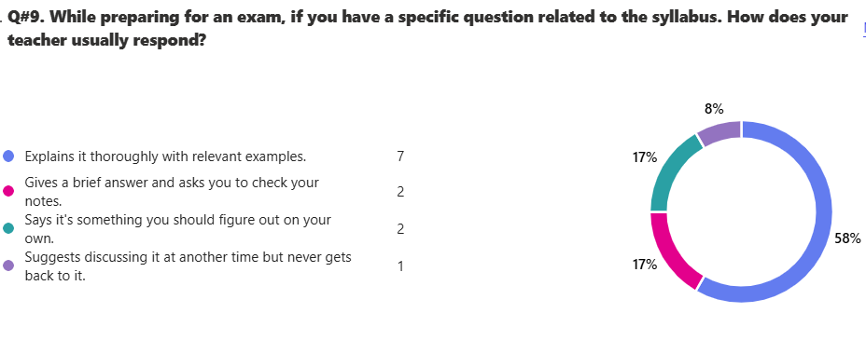
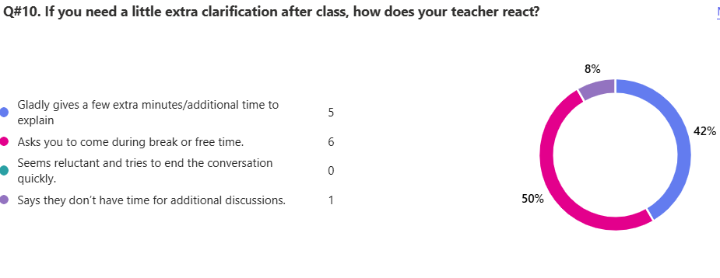
13. Any feedback that you would like to share with Board of Directors.
10 responses

ID | Responses
1 | no
2 | no
3 | the teachers are great but I think that there should be less students in classes, so they get personalized attention
4 | th teachers are nice but some get abit angry sometimes on littal things thank u
5 | no thank you my overall experience till now has been good as i am new and i am trying to understand everything but hopefully the teachers help me with what i want and i feel like the one thing is the teachers shouldnt only focus on the students with the good grades they should focus on each child individually thank you
6 | No
7 | i really love how the teachers explain every thing briefly leaving us with no confusion.the teachers for ig1 are very good,helping with with the upcoming exams of igs and future papers like O and Alevels papers.no need for improvement but some teachers dont usally explain their notes properly and the notes are completely not understandable.i would request you to keep checking the notes of the teachers especially the geo teacher.THE NOTES SHOULD HAVE THE VOCABLARY ACCORDING TO THE GRADE LEVEL THE TEACHERS ARE TEACHING!!.
8 | Overall, all the teachers are great in teaching but i have some difficulties in urdu the teacher doesn't bother helping,the teachers give alot of work in one class its quite hard to complete because they change the slides to fast.some teachers should imprve their way of teaching.
9 | School is great with discipline but some teachers are very rude in class specially english and urdu the canteen is way to dirty so are the washroom and also if any pAarent is calling to pick early the teachers doesent let go even if the admins have told them there are many emergencies so teachers should respect them but overall the school is 6 out of 10 thankyou!
10 | The teachers are gladly amazing,well qualified and experienced.Sir Taha and Saqib makes us understand the subject nicely,shares his experience aswell and also adds a bit fun.Ms Inshaal engages us in fun conversation while staying on topic making the class joyful and knowledgeable at the same time.Ms Naureen allows us to freely ask questions comes to us to check our progress in routine and is really qualified.Ms Fauzia makes us feel , we are in the right hands by telling us her students outstanding results.Ms Samira uses her historical knowledge to teach.Ms Munazza is sweet and knowlegdeable.

